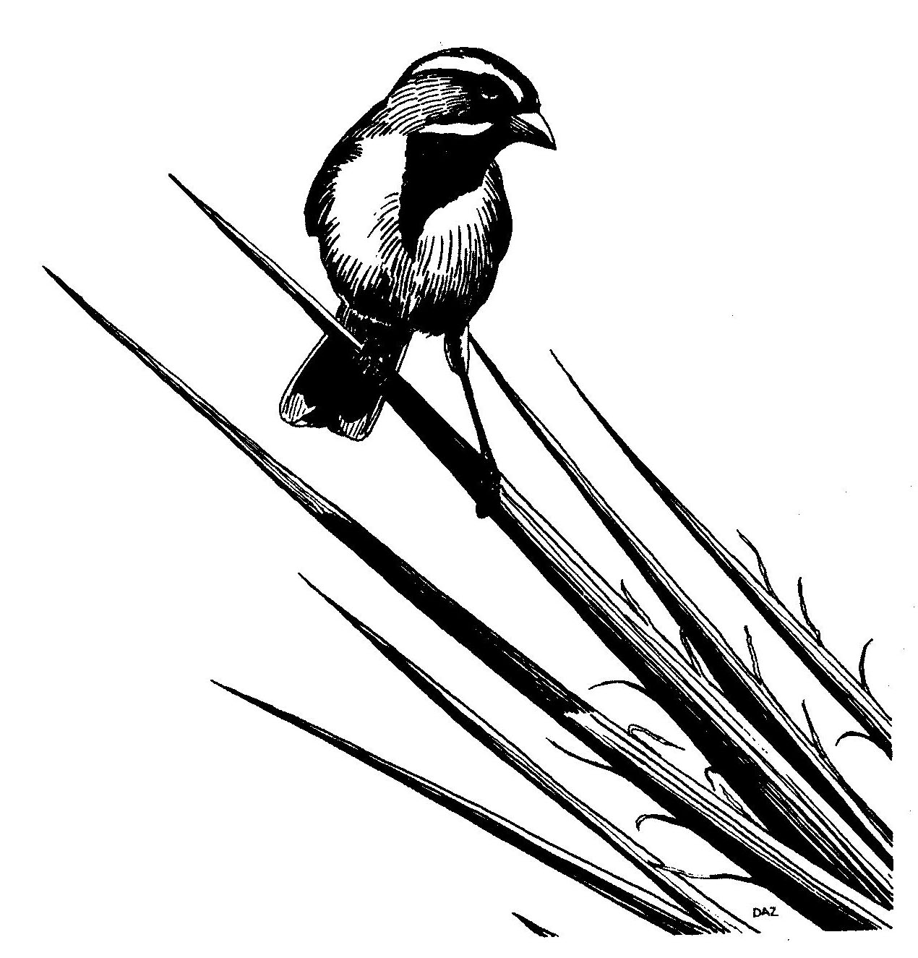
New Mexico Ornithological Society
Bird Records Committee Submittal Form

New Mexico Rare/Unusual Bird Report
This form is intended as a guide in reporting observations of unusual birds. It may be used flexibly and need not be used at all. Leave blank any details not observed. Attach additional sheets if necessary. Please print in black ink or complete electronically. Attach or include available photographs (electronic jpegs, or slides, prints), drawings, copies of field notes, etc.; include all photos of obscurely marked species. When completed, email or mail to: Dr. Sartor O. Williams III, New Mexico Bird Records Committee, email: sunbittern@earthlink.net (street address: 1819 Meadowview Dr. NW, Albuquerque, NM 87104). Thank you.
1. Common (and scientific) name:
2. Number of individuals, sexes, ages, general plumage (e.g., 2 ad. males in breeding plumage):
3. Locality (include County and distance from nearest named town):
4. Date(s) when seen:
5. Time(s) of day when seen:
6: Reporting observer (include middle initial, address, and e-mail address):
7. Other observers accompanying reporter who also identified the bird:
8. Other observers who independently identified the bird:
9. Light conditions (position of bird in relation to shade and to direction and amount of light):
10. Optical equipment (type, power, condition):
11. Distance to bird:
12. Duration of observation:
13. Habitat (general and specific):
14. Behavior (flying, feeding, resting, etc.; include and stress any habits used in identification):
15. Description (Include only what was actually seen, not what "should" have been seen. Include if possible: total length; body bulk; bill, eye, and leg characteristics; color and pattern of plumage, etc. Stress field marks. Be expansive; continue on back or on additional sheets):
16. Voice:
17. Similar species (include how they are eliminated by your observations):
18. Photographs (Was it photographed? By whom? Attached or emailed?):
19. Your previous experience with this species:
20. Aids: List books, illustrations, birders, etc., used in identification a) at time of observation; b) after observation:
21. This description written from: notes made during observation; notes made after observation; memory.
22. Are you positive of your identification? If not, explain:
23. Signature of reporter, along with date and time of writing of this account.

It is emphasized that a request for documentation is not an affront, but is an effort to substantiate a record by obtaining concrete evidence which may be permanently preserved for all to evaluate.

